Integration – substitution examples

Example 1 |  | Example 2
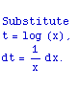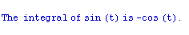  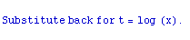 |  | 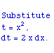  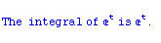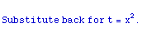 | 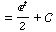  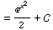
Example 3 |  | Example 4
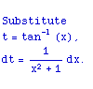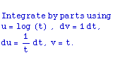  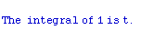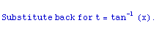 | 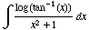 | 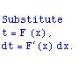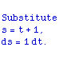  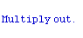  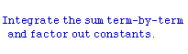  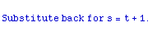  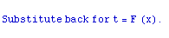 | 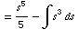  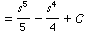
Example 5 |  | Example 6
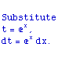  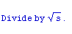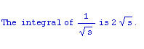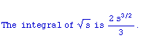  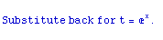 | 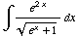  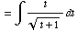  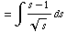  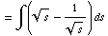  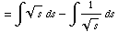  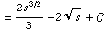 | 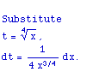  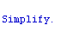  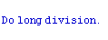  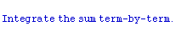  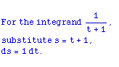  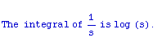  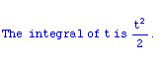  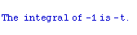  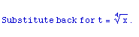 | 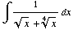  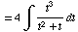  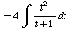

Example 7
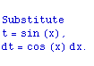  Factor the denominator into linear term  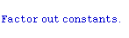  Split up the fraction into partial fraction  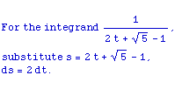  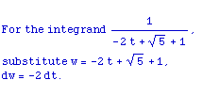  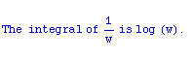 | 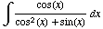  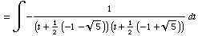  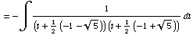  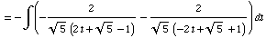  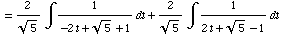  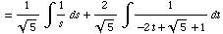  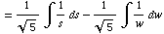  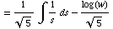 | 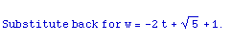  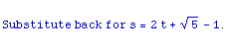  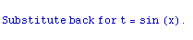 | 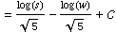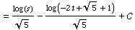  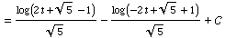  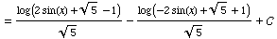  Example 8

